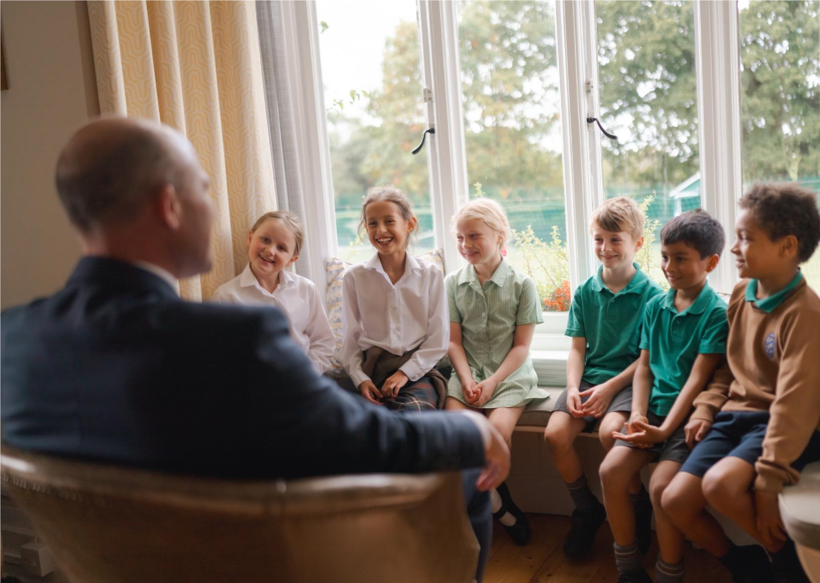

JOB DESCRIPTION

ONE TO ONE
TEACHING ASSISTANT

ABOUT US

Amesbury is a co-educational day school from 9 months – 13 years. We are looking for a suitably qualified teaching assistant to work with a child in Year 4 who has Developmental Language Disorder.

The main catchment areas for the school include Godalming, Haslemere, Midhurst, Petersfield and Farnham. The area is marked with outstanding nursery and school provision. Despite intense competition Amesbury has continued to be one of the strongest preparatory schools in the area and features in the Good Schools Guide. The School was last fully inspected by ISI in September 2017 and compliance inspected in July 2022. It was judged to be excellent in all categories and subcategories and fully compliant.
Children left the school in July 2023 for over 21 different senior schools, reflecting Amesbury’s independence, and there have been over 50 scholarships awarded to Amesbury pupils in the last three years. Since 2017 the school has invested over £3m in capital expenditure projects.
Amesbury is a day school, Monday to Friday. Registration is at 8.15am and school closes at 6pm. 5.45pm.
The school has a special energy and the people who work here are completely committed to both Amesbury as a school and as a place.

JOB DESCRIPTION

We are looking for a suitably qualified teaching assistant to work with a child in Year 4 who has Developmental Language Disorder.

This is a part-time position: Monday, Tuesday, Wednesday, and Friday 8.30am – 3.30pm and Thursday 8.30am – 1.00pm

Salary £23,000 to £25,000 depending on experience.

Start Date Michaelmas Term 2024

SCHOOL AIMS

Our principal purpose is quite straightforward. It is simply that we want every child to enjoy his or her time at school; to feel valued as individuals, in an environment where their talents can prosper to the benefit of the community, so that when the time comes to leave us, each child will so with confidence high, skills sharpened and personalities rounded.

More specifically we aim to:

- Develop in every child the necessary skills, aptitudes, and abilities to enable them to become emotionally resilient independent learners.
- Develop a caring community within the school by encouraging commitment, courtesy, cooperation, tolerance, and compassion towards one another whilst understanding that each individual is a member of a wider community.
- Promote and nurture a close relationship between home and school in the partnership of education.
- Provide all stakeholders with a model of organisational excellence.
- Create the circumstances in which all members of staff have the opportunity for personal development and feel able to make the fullest of contributions to school life.
- Fulfil our social and environmental responsibilities to society.

PERSONAL SPECIFICATION

Ideally you will:

    - Have the self-confidence, style, and communication skills to represent the school effectively to both parents and staff.
      - Taking the child out of the classroom for all English and Maths lessons and to provide appropriate language support, which will planned by English and Maths subject teachers at the pupil’s current level
      - Provide in-class support in all other curriculum subjects based on differentiated planning set by subject teachers
      - Attend the pupil’s private speech and language speech therapy sessions each week (for one hour per week) and support the child with therapy targets throughout the school week
      - Support the child with occupational therapy targets set by the occupational therapist throughout the school week (if advised)
      - Support the child during tutor times, morning breaks and most lunch times with social communication skills
      - To attend termly review meetings with parents in English and Maths, along with private therapists
      - To be a good communicator and work with the child’s form tutor, subject teachers, and the Head of SEND
      - To keep the child’s parents informed each week, regarding the child’s academic and pastoral support
      - To support subject teachers by preparing appropriate resources to be used with the child during lessons
      - To have a strong commitment to safeguarding the pupil (and others), and work with the school’s values and ethos in mind
    - To be accommodating and flexible in a changing environment, and to attend school trips with the child
    - Be able to maintain personal drive and energy, and to complete projects through to the end.
    - Be the absolute opposite of a clock watcher, wanting to go the extra mile and be able to convince others to do the same, with a ‘can do’ attitude.
    - It is the job holder’s responsibility for promoting and safeguarding the welfare of children for who s/he is responsible, or with whom s/he comes into contact, to adhere to and ensure compliance with the School’s Child Protection and Safeguarding Policy Statement at all times. If in the course of carrying out the duties of the role, the job holder becomes aware of any actual or potential risks to the safety or welfare of children in the School, s/he must report any concerns to the School’s Designated Safeguarding Lead or Deputy Designated Safeguarding Lead.

CHILD PROTECTION / SAFEGUARDING

Amesbury is committed to safeguarding and promoting the welfare of children and young people and expects all staff and volunteers to share this commitment. Our commitment is underpinned by robust processes and procedures that seek to maximise opportunity, minimise risk and continuously promote a culture of safeguarding amongst our workforce.

All successful applicants will be required to complete an enhanced DBS check which must be maintained throughout the period of employment.

